POLK-NORMAN-MAHNOMEN
COMMUNITY HEALTH SERVICES

COMMUNITY HEALTH IMPROVEMENT PLAN
Developed in years 2013-2014
For Implementation in 2015-2019
December 31, 2014

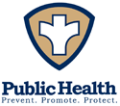

Polk County Public Health

Norman-Mahnomen Public Health

TABLE OF CONTENTS

Acknowledgements | 3
Letter to the Community | 4
Executive Summary | 5
Polk-Norman-Mahnomen Community Health Services | 6
Determining Health Priorities | 6
Community Prioritization Process | 7
Priorities Selected | 9
Addressing Social Determinants of Health | 12
Partnership Tool | 12
Decrease Persistent Poverty | 14
Coordination of Behavioral and Physical Health | 25
Positive Social Connections for Youth | 36
Call to Action | 42
Sustainability | 43
End Notes | 45
Appendix 1: Partnership Tool | 51

ACKNOWLEDGEMENTS

“Never doubt that a small group of thoughtful committed citizens can change the world; indeed, it’s the only thing that ever has.”- Margaret Mead

PNM CHS would like to thank the following people and organizations for participating in the planning that led to this report:
Shannon Kronlund | Northwestern Mental Health Center
Chris Kujava | Norman County Social Services
April Grunhovd | Riverview Health
Ben Fall | Norman County Sheriff’s Office
Julie Hanson | Mahnomen County Social Services
Jason Carlson | Tri-Valley Opportunity Council
Tracy Smith | Polk County Social Services
Velma Axtell | Polk County Social Services
Sheila Razmyslowski | Polk County Social Services
Patty Herndon | Polk County Social Services
Dan Svedarsky | University of Minnesota, Crookston
Cindy Bruun | Altru Health System
Chris Bruggeman | Riverview Health
Shannon Stassen | City of Crookston
Sue Knutson | Altru Health System
Candy Keller | Essentia Health - Fosston
Danica Robson | Area Agency on Aging
Michael T. Norland | Polk County Sheriff’s Office
Erin Stoltman | Essentia Health – Ada
Susan Klassen | Sanford Health/Mahnomen Health Center
Rhoda Habedank | Norman County East Schools
Al Brooks, Pastor | Wild Rice Parish Twin Valley
Leah Pigatti | Mahube-OTWA
Jeff Cadwell | City of Mahnomen
Jeff Bisek | Mahnomen School
Brian Clarke | Fertile-Beltrami School
Mike Hedlund | East Grand Forks Police Department
Tim Denney | Northwestern Mental Health Center
Kent Johnson | Polk County Social Services
Barbara Muesing | PNM Community Health Board Member/  Essentia Health Fosston Trustee
Shellie Bueng | Norman-Mahnomen Public Health
Sarah Kjono | Norman-Mahnomen Public Health
Kirsten Fagerlund | Polk County Public Health
Kathy Girdler | Polk County Public Health
Dawn Ganje | Northwest Minnesota Foundation
Terri Oliver | Polk County Public Health
Wendy Kvale | Minnesota Department of Health
Phyllis Brashler | Minnesota Department of Health
Becky Sechrist | Minnesota Department of Health
“If you want to walk fast, walk alone.
If you want to walk far, walk together.”- African proverb

LETTER TO THE COMMUNITY

Dear Polk, Norman and Mahnomen County Residents,

The 2015 Polk-Norman-Mahnomen Community Health Improvement Plan (CHIP) is the result of a robust Community Health Assessment process in which data was collected regarding the community health issues that are most important to Polk, Norman and Mahnomen County residents.

The CHIP is an action-oriented, living document to mobilize the community in areas where we can be most impactful on improving the health of residents, particularly those most vulnerable. It serves as a comprehensive set of policy and program recommendations for our community based on the most current information we have regarding the health status of our communities.

Clearly, health is influenced by things such as individual behaviors, age, genetics, and medical care. However, social and economic factors such as education, health insurance, employment and income, and living and working conditions all shape the overall health and vitality of our communities.

We envision a place where everyone has access to health care and preventative services, where we’re celebrated for embracing healthy lifestyles and where our communities and neighborhoods are strong and vibrant. As partners in the local health system, we recognize we can only achieve this goal through partnerships and positive changes at the individual, school, workplace, healthcare and community level.

This plan provides a foundation to stimulate strategic new partnerships towards a broad agenda to collectively influence a healthier region. Implementation of the Community Health Improvement Plan strategies and activities will commence beginning in the spring of 2015.

Sincerely,
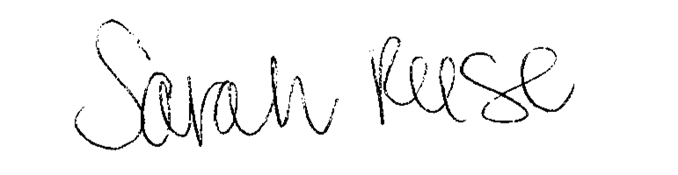 | 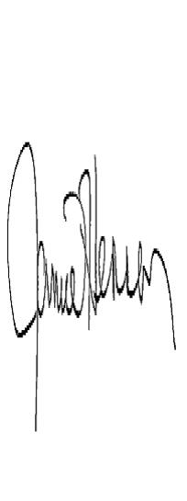
Sarah Reese, MS, CHES, Director | Jamie Hennen, RN, PHN, Director
Polk County Public Health | Norman-Mahnomen Public Health

EXECUTIVE SUMMARY

What do you think of when you think of the word “health”? Some people think about eating healthy, and some associate health with visiting the doctor’s office. Every day we make choices that affect our health- small things like choosing to floss our teeth or big things like making the decision to seek medical care. Some health-related decisions are made for you, like the passage of the Affordable Care Act, or recommendations by national associations. Benjamin Franklin said, “an ounce of prevention is worth a pound of cure,” we know that prevention is cheaper, more effective and better for the individual and society than addressing health conditions once they have been diagnosed. So, how can we, as a community, make a difference when it comes to health?

Health is a very large multi-faceted topic. Measuring health and effectively addressing health challenges requires an effort on behalf of a community. Measuring the health of Polk, Norman and Mahnomen counties was a large undertaking, which is why the process was conducted through a collaborative effort. Public health and community partners/stakeholders worked in partnership to conduct a comprehensive multi-county health assessment utilizing the Mobilizing Action through Planning and Partnership Process, the results which were published in the Community Health Needs Assessment in October 2013. In order to prioritize health issues and make sense of all of the data, stakeholders reviewed assessment results and met in June 2014 to prioritize issues that they felt were important to address, for the health of the community.

The priority areas that Polk, Norman and Mahnomen counties communities will be addressing include:
- DECREASE PERSISTENT POVERTY
- COORDINATION OF BEHAVIORAL AND PHYSICAL HEALTH SERVICES
- POSITIVE SOCIAL CONNECTIONS FOR YOUTH

The following document outlines the strategies that community groups and stakeholders are working on together in order to improve the health of residents of Polk, Norman and Mahnomen counties.

POLK-NORMAN-MAHNOMEN COMMUNITY HEALTH SERVICES

The Polk-Norman-Mahnomen Community Health Services (PNM CHS) comprised of Polk County Public Health (PCPH) and Norman-Mahnomen Public Health (NMPH) is a multi-county community health services entity responsible by Minnesota Statute 145A for protecting and promoting the health of Polk, Norman and Mahnomen County residents. The two public health departments are assigned the general authority and responsibility for ongoing planning, development, implementation and evaluation of an integrated system of local community health services.

DETERMINING HEALTH PRIORITIES

HOW DID WE GET HERE?

The purpose of the Community Health Improvement Plan is to identify how to strategically and collaboratively address community priority areas to improve the health and well-being of the community. A community-driven health improvement framework called Mobilizing Action through Planning and Partnership (MAPP) was used to guide the health improvement process.

The Community Health Needs Assessment is the document that was created from the first phase of the process in which the results and findings are detailed. The Community Health Assessment identifies and describes factors that affect the health of a population, and factors that determine the availability of resources within the community to adequately address health concerns. The Community Health Assessment, therefore, assures that local resources are directed toward activities and interventions that address critical and timely public health needs.

The Community Health Improvement Plan was guided by MAPP as well, and this document will detail strategic issues that came out of the assessment process and outline goals and strategies to address these health issues.

The data related to the health of Polk, Norman and Mahnomen counties that is referenced throughout this document and this report can be found in the on the county websites of each county.
Polk County www.co.polk.mn.us
Norman County www.co.norman.mn.us
Mahnomen County www.co.mahnomen.mn.us

PURPOSE

We recognize that by working together we can accomplish more than we could alone. The purpose of the CHIP is not to create more work for our partners, but to align and leverage the efforts of multiple organizations and to move toward improved health for the residents of PNM in a strategic manner.

What follows is the result of the community’s deliberation and planning to address health concerns in a strategic way that aligns resources and energy to make a measurable impact on health issues in PNM. We recognize that there are many assets in PNM that will help this process move toward accomplishing its goals.

COMMUNITY PRIORITZATION PROCESS

The first step to developing the Community Health Improvement Plan was to examine the results of the community health assessment for common themes and discuss what the assessments revealed about the health of our community. Through these discussions, several strategic issues, or things that need to be addressed in order to achieve the community health vision, emerged.

On June 13, 2014, twenty-eight (28)community representatives from the counties of Polk, Norman and Mahnomen met in Fertile, MN to determine the priority strategic issues necessary to build for the first time a regional Community Health Improvement Plan for the three county region. Prior to the community prioritization meeting, the stakeholders in attendance were emailed the community health needs assessment and tasked with reviewing the results. At the meeting, a summary of community health assessment findings were highlighted.

10 Most Important Community Health Issues*
1. Decrease persistent poverty
2. Older adults 65+ and resources for living safely alone
3. Preventing chronic diseases- cancer, diabetes, heart disease
4. Reduce teen pregnancy
5. Reduce children/adolescent obesity
6. Reduce tobacco use
7. Reduce drug abuse
8. Comorbidities of behavioral health and physical health
9. Increased positive role models/relationships early and often for youth
10. Reduce fatal and serious injury motor vehicle crashes

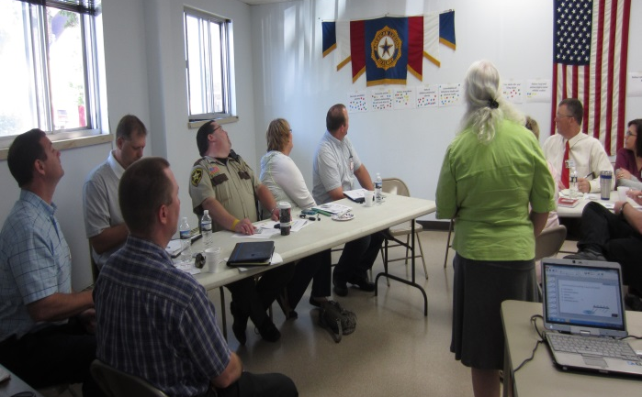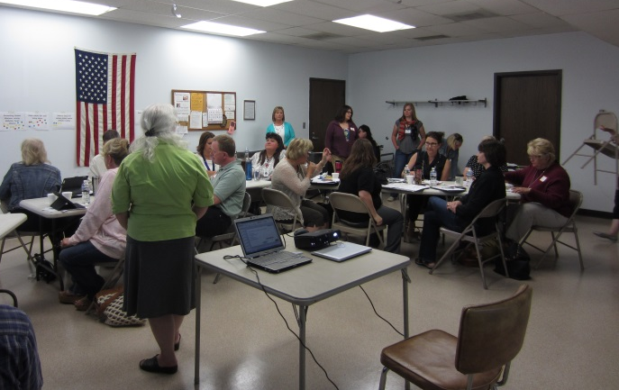*Identified in the recent Community Health Assessment and not numerically listed in order of importance

Each of the top 10 health indicators was written out on sheets of paper and put on a wall for stakeholders to prioritize. Two prioritization techniques were used for two rounds of prioritization. In round one, each participant was given for 4 sticky circle dots and they selected four health indicators from the master list of 10 using the “democracy” prioritization method. Each participant was allowed to use the four dots as they wished; hence more than one dot could have been placed per indicator.
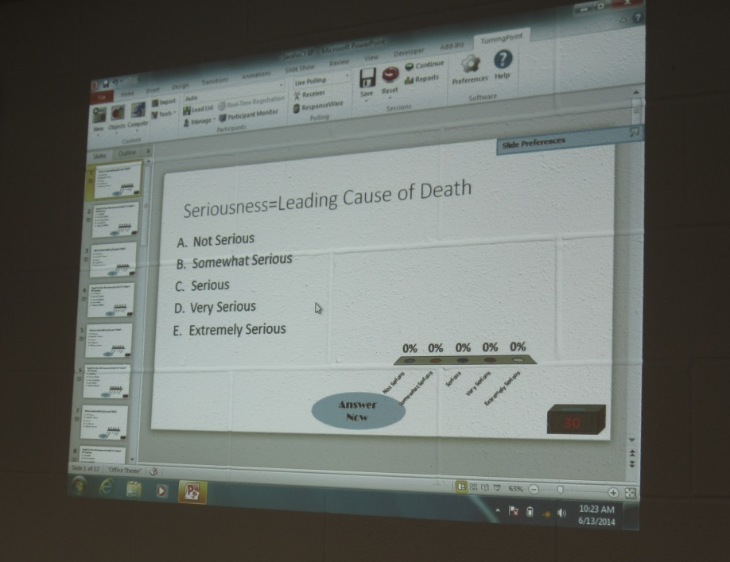
After all of the dots for each indicator were counted and the group discussed issues based on themes and relationships between and among issues, five indicators emerged for round two of the prioritization process. The indicators scored in round two involved a prioritization matrix comprised of two criteria:
- Seriousness (leading cause of death) and
- “Do”ability (can we make a difference).

Each participant used a clicker to score each of the 5 indicators twice according to a five-point scale: once for seriousness and once for “do“ability.

PRIORITIES SELECTED

In effort to keep the CHIP realistic and manageable, three strategic issues were chosen among partners to focus on for improvement. The resulting assignment of issues does not mean that any item is unimportant or not feasible, it only signifies what the group felt would be more serious and feasible at this time. Being able to show progress and accomplishments is important to the community leadership team and sustainability of the community health improvement projects. The group agreed that other issues may be added or removed from the plan as applicable.
To ensure readability, please note the icons below. Each icon corresponds to a different priority for action.
 | Priority 1: DECREASE PERSISTENT POVERTY
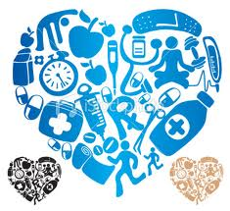 | Priority 2: COORDINATION OF BEHAVIORAL AND PHYSICAL HEALTH SERVICES
Priority 3: POSITIVE SOCIAL CONNECTIONS
FOR YOUTH

In reviewing the prioritization results and a subsequent facilitated discussion, coalition members/organizational stakeholders gave input on each priority area and identified that some of the indicators were inter-related. The team believed that this first regional effort must remain manageable and not duplicate other efforts in the community.
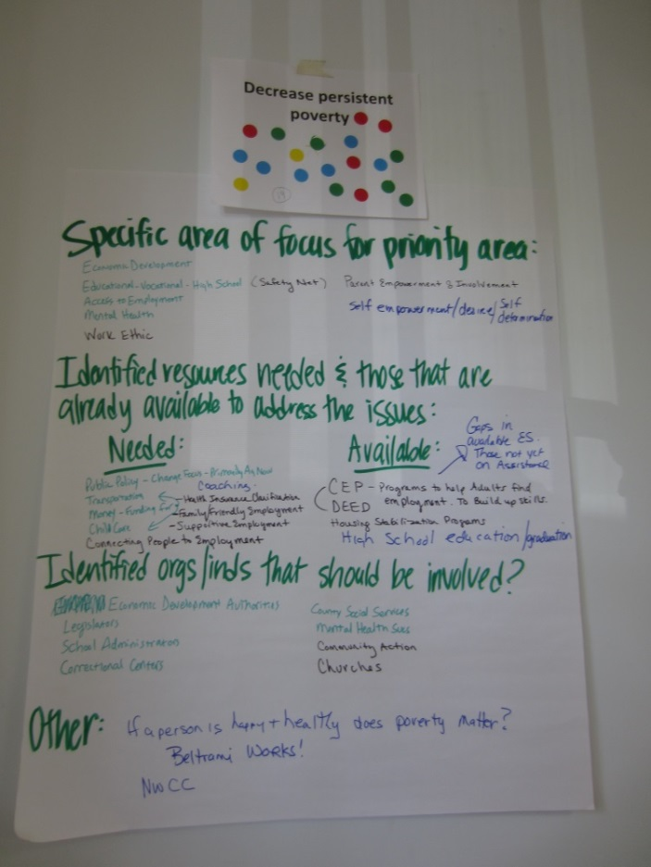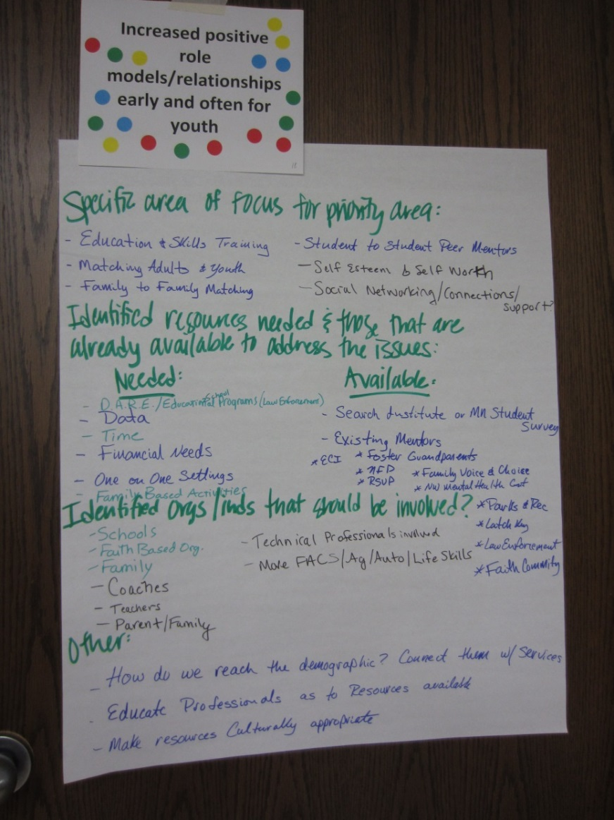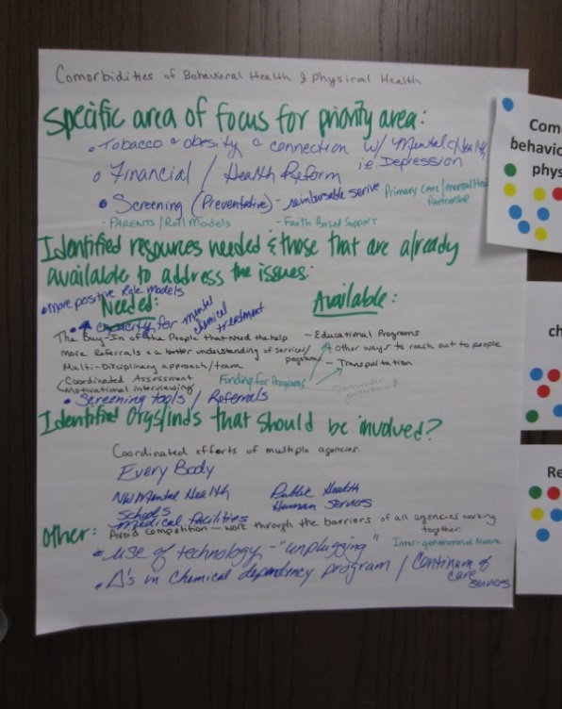

ADDRESSING SOCIAL DETERMINANTS OF HEALTH
The group felt the issues around economic disparities were important enough to have their own priority and participants voiced interest that other priority areas should address the social determinants of health with health equity in some way. Not addressing the social determinants of health would undermine the good work that is being undertaken in the other priority area.

Public Health Administration has longed expressed that the environments and financial resources (or lack thereof) in which people live, work, learn and play have a tremendous impact on their health. Administration acknowledges its surprise to the group’s interest in the importance of addressing the social determinants of health, such as economic opportunities, transportation, education and more. The bottom line is that no matter how we look at health, our coalition members, community stakeholders and partners are saying and prioritizing the need to collaboratively address these highly complex and often linked challenges- ultimately effecting health.

PARTNERSHIP TOOL
The partnership tool (Appendix 1) was distributed to organizations and persons assisting in establishing the “priority areas” as well as additional potential partners/stakeholders. It is understood and anticipated that the community may not be able to implement all of the strategies recommended in the Community Health Improvement Plan but rather a selection of those with significant interest, readiness and capacity as we explore, plan and implement mutually beneficial strategies.

The partnership tool defined a “lead, partner or support organization” and collected responses as to how partner organizations envisioned their role. Additionally, partners were asked to review the work plan and provide input for clarity on the strategies and outcomes.

- Lead Organization: A lead organization takes a primary responsibility for implementing a particular strategy, which may include any of these: staff time, organizational resources, internal funding realignments, program development, maintaining a multi-sectored coalition, developing collaborative partnerships, marketing/public relations to increase the community’s capacity to address the issue or rigorous advocacy for policy changes.

- Partner Organization: Organizations are visible partners along with other entities in the community; take on a significant role in accomplishing the strategy.

- Support Organization: This category includes a variety of actions that indicate that the organization will support a strategy. Support may include willingness to serve on an existing coalition or workgroup, prioritizing local funding to encourage adoption of a strategy, or willingness to serve as an advocate on the issue in your own circle of influence.

Public Health will serve as a “collaborative convener” to engage, support and/or bring together partners with missions that align with the goals of the action plan to improve community health through community member and partner engagement.

DECREASE PERSISTENT POVERTY
  - How can we increase availability of living wage jobs?
  - How can we, as a community, assure that everyone has
  - basic resources to live in good health?

CURRENT SITUATION

Poverty level is one of the most critical characteristics that contribute to the number of individuals experiencing preventable chronic diseases. Decreasing persistent poverty specifically unemployment and underemployment were identified as one of the three highest priorities. This belief was supported by the Community Health Assessment where the 5-year unemployment rate within Norman-Mahnomen (6.1) is higher than the state average of 5.2, whereas in Polk County it is 5.1. Additionally, educational levels of area residents are substantially lower than in comparison to the rest of the state. Between 47-55% of the population in the region aged 25 and older has less than or equal to a high school education or equivalent compared to 37% of the population statewide.

According to the Kids County Data Center, in 2011, 12% of Minnesota people were living in poverty. There is a culture of extreme poverty, as Mahnomen County ranks the poorest county in the state of Minnesota with 50% of people of all ages living at or below 200% of poverty and all 3 CHB counties exceed the state average of 26% of people living at or below 200% of poverty (2012 MN County Health Tables). These poverty statistics parallel the percentages of people who are uninsured.

Asset poverty is an economic and social condition that is more persistent and prevalent than income poverty. It can be defined as a household’s inability to access wealth resources that are sufficient enough to provide for basic needs for a period of three months. While 20.7 percent of all Minnesota households are asset poor, 43.3 percent of Native Americans in Minnesota are asset poor. Low-income households are more likely to be asset poor, the issue goes well up the income scale. Nearly one-quarter of households with incomes of $37,741 to $59,604 live in asset poverty.

Most of the participants agreed with the notion that there were not usually easy answers to this issue- that often, the root causes of the stemmed from circumstances and situations that were in place decades in the past, and potentially resulting from things outside of an individuals’ control.
Responses from the participants related to specific area of focus/identified resources needed was the concept of empowerment, coaching, access and connection to employment. It was noted that the Northwest Council of Collaboratives also identifies unemployment and underemployment as an important issue. Recognition of the effects of unemployment and low paying jobs on the health of community members was determined to be a priority for strategic planning.

The Roadmap and Results-Based Accountability

Polk-Norman-Mahnomen Community Health Services (Polk County Public Health and Norman-Mahnomen Public Health) like other areas across the country are interested in cross-jurisdictional sharing (CJS) arrangements. CJS is a deliberate exercise to enable collaboration across jurisdictional boundaries to deliver essential public health services.

We recently participated in a national Shared Services Learning Community. The Center for Sharing Public Health Services created “A Roadmap to Develop Cross-Jurisdictional Sharing Initiatives” to help guide jurisdictions through the process of considering or establishing cross-jurisdictional sharing (CJS) arrangements.

There are three distinct phases on the roadmap:
• Phase One: Explore
• Phase Two: Prepare and Plan
• Phase Three: Implement and Improve

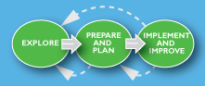

Collaboration allows communities to solve problems that cannot be solved — or easily solved — by single organizations or jurisdictions. Some of the issues, such as “decreasing persistent poverty” are highly complex and generational issues.
While the roadmap was developed for public health services, the guide is applicable, and will be used by stakeholders and interested parties in improving effectiveness and efficiencies around common topics and goals found within the improvement plans.

Results-Based Accountability, or RBA, is a way of thinking that can be used to improve the quality of life in communities. It’s made up of two parts:
- Population Accountability: wellbeing of whole populations (community, county, state)
- Performance Accountability: wellbeing of customer populations (programs, agencies, service systems)
RBA uses a data-driven, decision-making process to help us to get beyond talking about problems to taking action to solve problems. It focuses on “common language, common sense and common ground”. RBA asks three simple questions to get at the most important performance measures:
- How much did we do?
- How well did we do it?
- Is anyone better off?
Suggested Actions from the Facilitated Discussion - Decreasing Persistent Poverty
SPECIFIC AREA OF FOCUS FOR PRIORITY AREA:
• Economic Development
• Educational-Vocational-High School (Safety Net)
• Access to Employment
• Mental Health
• Work Ethic
• Parent Empowerment and Involvement
• Self-empowerment/Desire/Self-determination

IDENTIFIED RESOURCES NEEDED & THOSE THAT ARE ALREADY AVAILABLE TO ADDRESS THE ISSUES:
Needed:
• Public Policy – Primarily Agriculture Now
• Money – Funding for Childcare, Transportation
• Connecting People to Employment
• Coaching
• Health Insurance Clarification
• Family/Friendly Employment
• Supportive Employment
Available:
• CEP/DEED-Programs to help adults find employment/build up skills
• Housing Stabilization Programs
• High School Education/Graduation

Suggested Actions from the Facilitated Discussion - Decreasing Persistent Poverty
IDENTIFIED ORGS/INDS THAT SHOULD BE INVOLVED?
• Economic Development Authorities
• Legislators
• School Administrators
• Correctional Centers
• County Social Services
• Mental Health Services
• Community Action Agencies
• Churches

OTHER:
• If a person is happy and healthy does poverty matter?
• Beltrami works!
• NWCC

DECREASE PERSISTENT POVERTY
  - How can we increase availability of living wage jobs?
  - How can we, as a community, assure that everyone has
  - basic resources to live in good health?

GOALS | OBJECTIVES | STRATEGIES |  | LEAD (BOLD)  PARTNER or SUPPORT ORGANIZATION
Goal  Collaboration | Increase partnerships between organizations addressing poverty | 1. Establish clarity of objectives  2. Assess trust using the organizational “Trust Scale”  3. Train partners on principles of successful cross jurisdictional planning and sharing  4. Communicate information about what contributes to poverty and how it can be addressed |  | - Community Action Agencies  - Social/human services  - Public Health  - Behavioral health  - Clergy  - Hospitals/ clinics  - Schools  - Businesses  - Law Enforcement
 | Increase the number of agencies and organizations that are formal partners in the ongoing Community Health Improvement process | 1. Explore  Why? Articulate why this is important.  Assess trust using the organizational “Trust Scale”  What? Goals being considered (functions/programs/ capacity).  How can we mitigate current gaps?  Who? Partners that should be involved and how  2. Prepare and Plan  How exactly will it work? Establish clarity of objectives?  3. Train partners on principles of successful cross jurisdictional planning and sharing |  | - Public Health  - Hospitals/ clinics  - Community Action Agencies  - Behavioral health  - Social/ human services  - Schools  - Businesses
Goal  All people have opportunity for increased living wage jobs  & resources that meet their family’s needs | Enhance partnerships for increased qualified candidates for employment thru workforce development (school/college/community) | 1. Explore  Why? Articulate why this is important (cycle of poverty, local needs, Private vs. Public)  What? Goals being considered (functions/programs/ capacity). (such as career academies*, career pathway and bridge programs*, dropout prevention programs*) (*Scientifically Supported- County Health Rankings)  How can we mitigate current gaps?  Who? Partners that should be involved and how  2. Prepare and Plan  How exactly will it work utilizing a health equity lens? Ex. increased advocacy and coordination of support services - address fiscal and service implications, logistical issues, communications, change management, timeline  3. Implement and monitor  4. Support Northwest Council of Collaboratives current efforts  5. Support NW MN Foundation- Impact 20/20 Initiative- currently hosts workforce and education taskforces |  | - Community Action Agencies  - Hospitals/ clinics  - Behavioral Health  - Public Health  - Employers  - Northwest Council of Collaboratives members  - Northwest Minnesota Foundation  - Workforce Development Center  - Higher Education  - Northwest Services Cooperative Adult Basic Education
 | Increased quantity and quality of safe, affordable housing |  | 1. Use RBA to Explore  Why? Assess future needs, priorities and barriers  What? Healthy, safe and affordable housing  Who?  -Support and learn from Tri-Valley’s housing feasibility study currently underway in Crookston  -Engage NW Regional Development Commission, Headwaters Regional Development Commission and NW MN Foundation regarding their regular communication about affordable housing  2. Prepare and Plan  How exactly will it work utilizing a healthy equity lens?  -Support Public Health’s Healthy Homes grant to complete 100 Healthy Homes assessment and mitigate hazards as applicable  3. Implement and monitor | - Community Action Agencies  - NW Regional Development Commission  - Headwaters Regional Development Commission  - NW Minnesota Foundation  - HUD  - Economic Development  - City Planning and Zoning  - Public Health- Healthy Homes
 | Increased safe and affordable modes of transportation and non-motorized safe routes |  | 1. Use RBA to Explore- Motorized transportation and non-motorized safe routes  Why? What? Who?  2. Prepare and Plan  How exactly will it work utilizing a health equity lens? Such as, what are existing and potential funding streams that can assure adequate and sustainable operational funding?  -Support the Transportation Advisory Committee convened by Tri-Valley  3. Implement and monitor | - Community Action Agencies  - Wellness Coalitions/ Workgroups  - City  - Employers  - Transit Services  - Public Health- Statewide Health Improvement Program Safe Routes  - Transportation engineers  - Clergy
 | Increased access and decreased barriers to childcare services |  | 1. Explore – Use RBA to explore current situation and desired outcomes for feasibility  Why? What? Who?  (such as increased funding for childcare subsidy*)  -Support Community Action Agencies: Child Care Aware, Head Start and transportation options  -Engage with NW MN Foundation, Child Care Assistance Program, MN Dept of Education, MN Dept of Health and the Children’s Finance to build quality childcare  2. Prepare and Plan  How exactly will it work?  3. Implement and monitor  -Social Services advocate for changes through the MN Association of County Social Services Administrators  -Social Services continue to actively recruit foster and child care | - Community Action Agencies  - Human/ Social Services  - Employers  - NW MN Foundation  - Child Care Assistance Program  - MN Dept of Education,  - MN Dept of Health  - Children’s Finance  - Childcare Licensors  - Childcare Associations
Goal  Reduce stress associated with poverty | Increased focus on stress management (including financial literacy and overall mental health) |  | 1. Use RBA to Explore  Why? What? Who?  2. Prepare and Plan  How exactly will it work?  3. Implement and monitor  -Support Family Assets for Independence in Minnesota (FAIM) which connects low-income Minnesotans with asset building opportunities through the innovative use of Individual Development Accounts (IDAs), financial literacy education, personalized coaching and access to economic security support services.  -Social Services assist people with serious and persistent mental illness to address financial and budgeting matters | - Behavioral health  - Human/ Social Services  - Public Health  - Hospitals/clinics  - Community Action Agencies  - Employers  - Wellness Coalitions/ Workgroups  - Clergy

Outcome Indicators

- Documentation of organizations collaborating (common goals, trust, team approach, training, apply for funding) for the purpose of continuous community health improvement addressing poverty and health equity throughout the process.
- At least three strategies will be implemented to help meet the goal. (annual progress review)
  - Explore: Conceptual feasibility study/established vision for project strategies
  - Prepare and Plan: Implementation plan/determine baseline and establish measurement targets
  - Implement and Monitoring: progress and evaluation reports, knowledge-sharing documents, quality improvement reports, revised plans
- The Northwest Council of Collaboratives will consider health equity when reviewing monthly grant opportunities.
- Documentation of the Community Health Board and Community Leadership Team discussion on health equity to address policy, system and environmental change in Polk, Norman, and Mahnomen.
- A formal training on cross jurisdictional planning and sharing for least 3 community collaboratives across the 3 county area.
- Public Health will have 65% of sectors represented and engaged in community health improvement assessment and improvement plan. (letters of support and participation)
- Qualitative findings related to “opportunities for health” (Theme from Minnesota Statewide Health Assessment)
- Decrease in dropout rates and increase in the % of students who graduate high school. (MDE) (VS Trends) (Rationale: Education often results in higher incomes, on average, and more resources than a job that does not require education).
- Percentage of adults with a living wage job and income.
- Percentage of adults who have an industry recognized credential (Bureau of Labor Statistics)
- Percentage of high school students participating in job preparedness programs or curricula (survey)
- Percentage of related children ages 5 to 17 in families in poverty (Census Bureau)
- 100 healthy home assessments will be completed by public health across the 3 counties improving healthy home environments for citizens.
- Increase transportation opportunities to support employment: Number of communities served, Number of days served, Number of trips made, Number of riders (transit data)

*Outcome Indicators to be refined as needed

COORDINATION OF BEHAVIORAL AND PHYSICAL HEALTH SERVICES
  - How can we strengthen communication and coordination among health care and community partners to support healthy behaviors across the life span?

CURRENT SITUATION

A second priority identified was health behaviors related to the comorbidities of behavioral health and physical health. Specific “unhealthful behaviors” identified from the discussion were eating behaviors, lack of physical exercise, tobacco use, and drug abuse (legal and illegal). Further conversation led to the group combining “reducing drug abuse” and “reducing children/adolescent obesity” within focus area of addressing “comorbidities of behavioral health and physical health”. More specific issues teased out were a multi-disciplinary approach/team, coordinated assessment/screening (screening tools/motivational interviewing), referrals (with better understanding of community/healthcare services/programs), and financial reform for preventatives services.

Minnesota Student Survey (MNSS) results for area 12th graders indicate that overall, those students within the 3-county region are significantly more overweight than other 12th graders from across the state, and furthermore they are significantly more likely to believe they are overweight than other seniors from across the state. Consumption of fresh fruits, vegetables and other nutritious foods and regular physical activity are critical to attaining and maintaining a healthy weight. The Behavioral Risk Factor Surveillance Data suggest that lack of exercise for adult populations within the three counties may be a significant issue as nearly 18% of residents in each county are estimated to not participate in any form of exercise compared to the state average of nearly 13%.

Drug use/abuse was considered to be one of the most risky behaviors in the community. Ben Fall, Norman County Chief Deputy, states “There are many people in our area who are directly affected by the use of illegal drugs. We are also seeing firsthand, the effects that the misuse and abuse of prescription drugs is having on our population, including children and young adults. These children and young adults are experiencing this on their own, through a family member, friend, neighbor or sometimes even a co-worker.”

Tobacco is a leading cause of death and preventable disease among the PNM CHS area. Young people from low-income families are roughly twice as likely to smoke cigarettes. Thirty-one percent of 12th grade students across PNM CHB smoked a in the previous 30 days as compared to 22% statewide (MN Student Survey 2010). Also of great concern for the region is the reported frequent use of smokeless tobacco.

Excerpts from the “Findings and Recommendations based on the 2011 Minnesota Behavioral Risk Factor Surveillance System- Executive Summary” state,
“Minnesota Department of Health has collected data regarding the effects of adverse childhood experiences (ACEs) on the lifelong health and well-being of adults in Minnesota. For two decades, research by the Centers for Disease Control and Prevention (CDC)
and other states has demonstrated over and over again the powerful impact of ACEs on health, behavioral, and social problems.

An adverse childhood experience (ace) describes a traumatic experience in a person’s life occurring before the age of 18 that the person recalls as an adult. In the Minnesota BRFSS survey, respondents were asked if they had experienced any of the following nine types of ACEs: physical abuse, sexual abuse, emotional abuse, mental
illness of a household member, problematic drinking or alcoholism of a household member, illegal street or prescription drug use by a household member, divorce or separation of a parent, domestic violence towards a parent, and incarceration of a household member.

Results indicate that ACEs are common among Minnesota adults. Over half of the Minnesotans responding to ACE module questions reported experiencing at least one ACE in childhood. The five most common ACEs reported by Minnesotans in the survey are emotional abuse (28 percent),
living with a problem drinker (24 percent), separation or divorce of a parent (21 percent), mental illness in the household (17 percent),
and physical abuse (16 percent).

As the number of ACEs increases, the risk for health problems increases
in a strong and graded fashion in areas such as alcohol and substance
abuse, depression, anxiety, and smoking. ACEs have a strong
and cumulative impact on the health and functioning of adults in Minnesota.”

To understand the impact of mental illness we can look at individuals with a chronic behavioral health disorder such as schizophrenia, bi-polar and major depression. They are at a greater risk of having a co-occurring physical and behavioral health disorder. Due to the pharmacological interventions to manage behavioral health symptoms, they experience significant side effects that cause physical health disorders such as diabetes, obesity and cardio vascular disease. As a result, individuals with a co-occurring disorder have a mortality rate 8-25 years earlier than the general population.

Public Health’s, Statewide Health Improvement Program (SHIP), helps Minnesotans live longer, healthier lives by preventing the leading causes of chronic disease: tobacco and obesity. SHIP launched as part of Minnesota’s Vision for a Better State of Health, was a bipartisan health reform package enacted in 2008. Evidence based chronic disease strategies utilizing policy, system and environmental changes make it easier for Minnesotans to have healthy choices where we live, learn, work, play and seek healthcare. Public Health and its community/healthcare partners seek to achieve more equitable health, where people are able to attain their highest level of health possible.

The SHIP Model: Improving health by increasing opportunities for healthy choices
Increased opportunities for physical activity, nutritious food and tobacco-free living… | means more people get physical activity, better nutrition and less tobacco exposure… | leading to improved health… | and lowered health care costs and improved quality of life.

Suggested Actions from the Facilitated Discussions –Coordination of Physical and Behavioral Health
SPECIFIC AREA OF FOCUS FOR PRIORITY AREA:
• Tobacco & Obesity and Connection with Mental Health (i.e. Depression)
• Financial/Health Reform
• Screening (Preventative) – Reimbursable Service
• Parents/Roll Models
• Faith Based Support
• Primary Care/Public Health/Mental Health Partnership

IDENTIFIED RESOURCES NEEDED AND THOSE THAT ARE ALREADY AVAILABLE TO ADDRESS THE ISSUES:
Needed:
• More Positive Role Models
• Capacity for Mental & Chemical Treatment
• Client/patient buy-in/trust
• More Referrals & a Better Understanding of Services/Programs
• Multi-Disciplinary Approach/Team
• Coordinated Assessment
• Motivational Interviewing
• Screening Tools/Referrals
• Funding for Programs

Available:
• Educational Programs/Other Ways to reach out to people
• Transportation

IDENTIFIED ORGS/INDS THAT SHOULD BE INVOLVED?
• Coordinated efforts of multiple agencies
• Everybody
• NW Mental Health
• Schools
• Medical Facilities
• Public Health/Human Services

OTHER:
• Avoid Competition – work through the barriers of all agencies working together
• Use of Technology – “Unplugging”
• Changes in Chemical Dependency Program/Continue of Care Services
Suggested Actions from the Facilitated Discussions (continued)
• Inter-Generational Nature

Healthcare partners are operating in silos. The critical access hospitals, primary care, behavioral health, public health and social services are fiscally vulnerable and challenged to meet the requirements for electronic medical records, system and technological improvements. Health reform will require system improvements to broaden and deepen the involvement of multiple stakeholders on policy, service and assessment issues. Healthcare partners should utilize a multi-disciplinary team to increase integration and coordination of services across the continuum of care and increase connection of individuals to the preventative screening and health services they need.
Healthcare partners should engage the client/patient in a two-way information exchange where the clinician can share options, benefits and harms and the client/patient can share their level of risk tolerance, values, and preferences for care.
Healthcare providers should go beyond providing medical service by serving as a source of preventative health information and should gain a better understanding of services/programs available to provide patients more referrals to community supports.
Client/patient navigators should be considered/utilized to create buy-in and develop trust and rapport with clients/patients who are experiencing a co-occurring physical and behavioral health disorder.
Support the use of health care extenders (i.e. health educators, community paramedics, nutritionists, etc.) to improve engagement of disparate populations in evidence-based lifestyle change and prevention programs.

COORDINATION OF BEHAVIORAL AND PHYSICAL HEALTH SERVICES
  - How can we strengthen communication and coordination among health care and community partners to support healthy behaviors across the life span?

GOALS | OBJECTIVES | STRATEGIES | LEAD ROLE  PARTNER or SUPPORT ORGANIZATION
Goal  Achieve the Institutes for Healthcare Improvement’s Triple Aim:  - Improve the health of the population;  - Improve the patient/consumer experience; and  - Improve the affordability of health care | Enhance coordination and integration of clinical, behavioral, and complementary health services. | 1. Explore  -Implement/ support effective care coordination models (i.e. medical homes, behavioral healthcare homes, etc)* (*Scientifically Supported- County Health Rankings)  -Integrate behavioral health into primary care practice*  -Reference Community Measures  -Social Services and Public Health professionals to work closely with providers in a way that is mutually beneficial  2. Prepare and Plan  How exactly will it work?  3. Implement and monitor | - Hospital/Clinics  - Behavioral Health  - Public Health  - Social/Human Services
 |  | Electronic health information exchange*-  Prepare and implement  the NW Minnesota E-Health Initiative  (shares information securely and safely; develop the technological infrastructure to share information for coordination of care; engage in Care Coordination Efforts and Integrated Health Partnership options) | - Stratis Health  - NW Mental Health Center  - E-Health Collaborative Partners
 |  | 1. Explore  -Engage primary care providers (and others in direct contact with individuals) in conducting screening and making referrals for these resources while using the evidence-based model* (screen, counsel and referral to treatment)  (such as chronic disease self- management programs*).  -Computerized clinical decision support systems*  -Reference Community Measures  2. Prepare and Plan  How exactly will it work?  -Motivational interviewing –patient shared decision making*  -Focus on holistic health  3. Implement and monitor | - Hospital/Clinics  - Public Health  - Behavioral Health  - Social/Human Services  - Clergy
 | Reduce the gaps in services and resources and increase the utilization of services and resources. | 1. Explore - Increased network of systems navigators  Individuals in each agency increase access to and support for utilizing resources to engage in healthy behaviors and preventative care.*  (*County Health Rankings Evidence Based/Promising Strategy).  -Support implementation of community-based preventive services and enhance linkages with primary care* (i.e. tobacco cessation; quitline and asthma home environment intervention program linked to clinicians as referral points).  -Reference Community Measures  Why? What? Who?  2. Prepare and Plan  How exactly will it work?  3. Implement and monitor | - Hospital/Clinics  - Public Health  - Behavioral Health  - Social/Human Services
 | Increase population’s understanding of the benefits of preventative care and reduce stigma related to A)having mental illness and B)seeking care for mental illness while reducing cultural and health literacy barriers | 1. Use RBA to Explore  Why? What? Who?  -Identify community events that reach out to target population  -Seek ways to integrate recommended preventive care services and expand health literacy.  -Offer Mental Health First Aid training  2. Prepare and Plan  How exactly will it work?  3. Implement and monitor | - Behavioral Health  - Public Health  - Hospital/Clinics  - Social/Human Services  - Community Action Agencies  - Law Enforcement  - Clergy  - Schools
Goal  To create an environment and culture, through policy and systems change, that makes physical activity and healthy foods easier and more rewarding for people of all ages and abilities. | Make it easier for residents to walk, bike, and wheel to everyday destinations | 1. Explore  Why? What? Who?  (such as improve streetscape design*, point of decision prompts*, land use master plans*)  2. Prepare and Plan  How exactly will it work?  3. Implement and monitor | - City  - Public Health (SHIP)  - Wellness Coalitions/ Workgroups  - Schools  - City and County Building/ Zoning/GIS  - Regional Development Commission  - Employers
 | Encourage active living at work | 1. Use RBA to Explore  Why? What? Who?  (such as worksites that have adopted policies supporting physical activity*)  2. Prepare and Plan  How exactly will it work?  3. Implement and monitor | - Public Health  - Employers  - Hospital/Clinics  - Schools  - County/City Wellness Coalitions  - Clergy
 | Increased access to healthy foods | 1. Use RBA to Explore  Why? What? Who?  (such as policies and environments supporting access/availability of healthy foods and/or breastfeeding promotion programs*)  2. Prepare and Plan  How exactly will it work?  3. Implement and monitor | - Public Health  - NW Regional Sustainable Development Partnership  - UMN Extension  - Employers  - Breastfeeding Coalition  - Wellness Coalition/ Workgroups  - Food Bank/Food Shelf  - Clergy
Goal  Prevent and address alcohol, tobacco and other drug (ATOD) use | Convene ATOD stakeholders to create a county-wide strategy to prevent and address ATOD use and misuse | 1. Explore  Why? What? Who?  2. Prepare and Plan  How exactly will it work?  3. Implement and monitor  Apply for funding that supports preventing and addressing ATOD use and misuse | - Public Health  - Wellness Coalitions/ Workgroups  - Behavioral Health  - Law enforcement  - Schools  - Tobacco and alcohol retailers  - Employers

Outcome Indicators

  - At least three strategies will be implemented to help meet the goal. (annual progress review)
  - Explore: Conceptual feasibility study/established vision for project strategies
  - Prepare and Plan: Implementation plan/determine baseline and establish measurement targets
  - Implement and Monitoring: progress and evaluation reports, knowledge-sharing documents, quality improvement reports, revised plans
  - E-Health: Completed Privacy and Security Risk Assessments, Minnesota Accountable Health Model: Continuum of Accountability Matrix, subscribe to a state certified eHealth option (direct or connect) to share information, implement strategies (direct/connect), identify and implement one Use Case scenario for using eHealth to advance care coordination)
  - Increase in the percentage of adults on medical assistance who have a personal health care provider (medical home). (National Quality Measures Clearinghouse/survey local healthcare partners)
  - Increase the number of healthcare providers trained to implement screen/counsel/refer/follow-up and/or motivational interviewing or similar efforts.
  - Increase the percentage of patients that have met the targets for preventative screenings (Community Measures/survey partners)
  - Increase the percentage of patients that have received evidence-based preventive treatment (Community Measures/survey partners)
  - Increase in the number of system/patient navigators in use in the three county area. (survey local partners)
  - Increase the amount of accessible safe routes and frequency of use of walking and biking routes (linear feet and Environmental Observation)
  - Increase the number of worksites that have existing or adopted policies supporting physical activity and/or nutrition. (survey)
  - Increase the availability of fruits and vegetables in food deserts through retail, gardens, and food banks (environmental observation)
  - Action plan for addressing and preventing ATOD created.

*Outcome Indicators to be refined as needed

POSITIVE SOCIAL CONNECTIONS FOR YOUTH
  - How can we promote and support social connection efforts and opportunities in our community?

CURRENT SITUATION

This priority strategic issue is a social determinant of health- meaning that a feeling of having social connections affects people’s behavior, which in turn affects health outcomes. People with more positive social connections are protected from poor health outcomes.

The Search Institute confirms that “both researchers and practitioners have long embraced the idea that interaction with caring adults is central to young people’s development.” New research finds that in addition to expressing care, “young people also need people in their lives who challenge growth, provide support, share power, and expand possibilities”. (2014, http://www.search-institute.org/sites/default/files/a/Dev-Relationships-Framework.pdf)

This issue is unique in that is focuses on a specific age group-youth. This is strategic for a number of reasons. First, we know that the health trajectory of an entire life is established very early on in child development. The negative impact of poverty on the developing brain means that children who are deprived will have worse health as adults, even if they practice good health behaviors. Behaviors are set very early in a child’s life and impacted by the role models and relationships in their lives.

Youth are a unique population in that they are “sponge”-constantly learning new information, skills and expectations (norms) about ways of acting and living that contribute to health and their future (or not). Additionally, children (because their brain is still developing) are much likelier (than adults) to be able to establish and sustain healthy behaviors based on positive adult role modeling and education. It is important to provide individuals, especially children, with knowledge, skills and tools to facilitate social connectedness and community engagement across the lifespan.

During the community dialogue issues related to child health and positive role models/relationships were repeatedly raised. The criteria used to determine the final strategic priority issues were: Seriousness and Do-ability. After voting and a hearty discussion, the participants ranked positive role models/relationships for children high in “seriousness” and “do-ability”.

Suggested Actions from the Facilitated Discussion- Positive Social Connections for Youth
SPECIFIC AREA OF FOCUS FOR PRIORITY AREA:
• Education and Skills Training
• Matching Adults and Youth
• Family to Family Matching
• Student to Student Peer Mentors
• Self-esteem and Self-worth
• Social Networking/Connections/Support

IDENTIFIED RESOURCES NEEDED AND THOSE THAT ARE ALREADY AVAILABLE TO ADDRESS THE ISSUES:
Needed:
• D.A.R.E./Educational School Programs (Law Enforcement)
• Data
• Time
• Financial Needs
• One-on-one Settings vs. Family Based Activities
Available:
• Search Institute or MN Student Survey
• Existing Mentors: ECI, Foster Grandparents, NFP, RSVP, Family Voice & Choice, NW Mental Health Center, Parks & Rec, Latch Key, Law Enforcement, Faith Community

IDENTIFIED ORGS/INDS THAT SHOULD BE INVOLVED?
• Schools
• Faith Based Org.
• Parent/Family
• Coaches/Teachers
• Technical Professionals involved
• More FACS/Ag/Auto/Life Skills

OTHER:
• How do we reach the demographic? Connect them with services.
• Educate professionals as to resources available
• Make resources culturally appropriate

POSITIVE SOCIAL CONNECTIONS FOR YOUTH
  - How can we promote and support social connection efforts and opportunities in our community?
GOALS | OBJECTIVES | STRATEGIES | LEAD ROLE,  PARTNER or SUPPORT ORGANIZATION
Goal  A thriving mindset producing  productive, happy, and contributing members of society | Increase social connectedness/ developmental relationships among youth | 1. Use RBA to Prepare and Plan - Fostering healthy relationships and positive mental health (such as mentoring*, home room time, summer learning programs*, NorthStar Summer Program)  (*Scientifically Supported- County Health Rankings)  2. Implement and monitor | - Behavioral Health  - Schools  - Law enforcement  - Mentors  - Public Health  - Clergy
 |  | Support and promote current  extracurricular activities and afterschool programs  When applicable, examine underutilization through RBA. | - Schools  - Activities Directors  - Parks and Recreation  - Clergy  - Mentors
 |  | Support School-Based (Policy/Social Capital) Interventions to establish safe and socially connected schools and provide individuals with knowledge, skills, and resiliency through:  -School based social and emotional development instruction* (such as school based mental health services)  -School based programs to reduce violence and bullying* (such as the DARE program- currently implemented in East Grand Forks by Police Department)  -Support and possibly expand the Students Teaching Attitudes of Respect (STAR) program: increase awareness for students in the areas of community building, media, skills needed to deal with conflict, and the utilization of personal power and strengths. The goal is to model and support a positive school culture. Currently offered at Norman County East, Naytahwaush and Waubun Schools  -Support NW MN Foundation’s offering of “Social and Emotional Learning” Trainings for school staff | - Schools  - Behavioral Health  - NW MN Foundation  - Law enforcement  - Public Health  - Social/Human Services
 | Increase health-related self-efficacy among children and their caregivers | Provide individuals with knowledge, skills, and self-esteem through:  -Parent and family skill based support programs that support positive family interactions* (such as school based mental health services or experiential education*) | - Behavioral Health  - Schools  - Public Health- Family Home Visiting  - Community Action Agencies  - Social/Human Services
 |  | Provide individuals with knowledge, skills, and self-esteem through:  -Increased early home visitation among high risk families* and Nurse Family Partnership* (2015- PNM CHS plans to expand NFP into Polk County) | - Public Health  - Community Action Agencies  - Behavioral Health  - Social/Human Services  - Schools  - Clergy
 |  | -Increase the proportion of children in poverty who participate in preschool programs (designed to improve cognitive and social development)* | - Community Action Agencies  - Early Childhood Family Education  - Schools  - Childcare Association
Goal  Personal and organizational ownership of the need for increasing social connectedness as a means of improving the health and wellness of the community, and creating a more inclusive community | Creation of wide-scale awareness for the value of and the processes for improving of social connectedness within organizations, the communities, and across the county’s | 1. Explore and identify the adaptive challenges to improving social connectedness, cultural inclusion, and better health and wellness in the organizations and communities  Why? What? Who?  2. Prepare and Plan  How exactly will it work?  3. Implement and monitor | - Public Health  - City’s  - UMN Extension  - Behavioral Health  - Social/Human Services  - Schools  - Clergy
 | Deliver high-quality facilitation that will focus on bridging relationships, linking social capital, population community health and mental health, cultural inclusion, and adaptive leadership for improving social connectedness and system transformation. | 1. Prepare and Plan: Facilitation for the development of “The Shift” in the thinking of individuals and the community in regard to prioritizing social connectedness, health and wellness, and cultural inclusion.  2. Implement and monitor | - Behavioral Health  - Public Health  - Northwest Council of Collaborative Partners  - Hospital/Clinics  - Employers
 | Increased connection of people to resources | 1. Prepare and Plan: Develop asset maps of organizational and social resources based upon increased participation and input from individuals and groups not normally “at the table” in systems transformation discussions, by means of social bridging, linking, and inclusion practices.  2. Implement and monitor | - Northwest Council of Collaborative Partners  - Hospital/Clinics  - Employers

Outcome Indicators

  - At least three strategies will be implemented to help meet the goal.
(annual progress review)
  - Explore: Conceptual feasibility study/established vision for project strategies
  - Prepare and Plan: Implementation plan/determine baseline and establish measurement targets
  - Implement and Monitoring: progress and evaluation reports, knowledge-sharing documents, quality improvement reports, revised plans
  - Community asset map developed defining existing resources and utilization.
  - Increase in the number of clients served by home visiting programs that begin prenatally.
  - Increase in child welfare referrals to a family home visiting program (public health, early head start, children’s mental health)
  - Increase the percentage of families receiving service coordination when multiple providers are serving a family.
  - Increase the number of children in poverty participating in preschool programs.
  - Increase the percentage of parents who have attended a family skills based training program
  - Increase the number of schools with a bullying prevention curriculum and/or policy.
  - Increase in the number of schools who are implementing evidence-based bullying prevention programs.
  - Training completed on social connectedness, health and wellness, and cultural inclusion.

*Outcome Indicators to be refined as needed

CALL TO ACTION

HOW CAN YOU HELP IMPROVE COMMUNITY HEALTH IN POLK, NORMAN AND MAHNOMEN COUNTY’S?

Throughout the planning process community members and organizations have been actively involved, and our goal is for that to continue! As you think about what you have read here, please think about ways YOU can contribute to building an even healthier region.

Community health improvement is not a static process. We promote a “Health in All things” approach to community health planning and are therefore looking for partners in a variety of sectors interested in partnering across the local public health system to help develop recommendations, implement strategies, and evaluate our efforts.

Here are some things you might consider:

Advocate for the plan’s adoption in your organization or other parts of the community

It is our goal that organizations from all sectors of the community – schools, health care providers, local government, faith organizations, service providers, and others – will actively adopt and participate in this community health plan.

In our daily lives we touch other’s lives throughout our community. Think about the specific opportunities for community action listed in this plan. How could some of these actions be supported in the places where you learn, work, and play? How can you personally help advocate change? Advocating for changes like this across all sectors of our community is important if we want to see true change.

Stay involved with groups working to implement the plan

Within the community there are already wellness coalitions and work groups that are active in efforts to improve community health.

If you, or your organization, are the missing partner in the CHIP please contact the Health Department to get more information about how you can help support our efforts to improve community health. We look forward to working with you!

SUSTAINABILITY

The community health improvement plan (CHIP) created by community members and organizations broadens and builds upon successful local initiatives. Leadership of the efforts and resources needed to implement the plan will be shared across participating community and healthcare partners. The health improvement plan identifies specific evidence-based components based on community health needs (including social determinants of health).
The first priority issue involves strengthening the local public health system partnerships and structure. If this structure is enhanced and maintained, it will provide a platform for ongoing community health improvement.
We recognize that if we are to achieve our vision for community health improvement in Polk, Norman and Mahnomen counties and successfully implement the strategies highlighted in this document, then we need to explore, plan, implement and promote policies, systems and environments that reinforce this effort. Therefore the policy, systems and environmental recommendations included are designed to address our collective public health concerns, guide the implementation of the strategies proposed in this CHIP, and promote a “health in all things” approach.
In order to meet public health standards, Polk County Public Health and Norman-Mahnomen Public Health are committed to facilitating implementation of the Community Health Improvement Plan.

Facilitated Discussion June 2014 Wendy Kvale, Nurse Consultant, Minnesota Department of Health, led participants in a facilitated discussion and rotation through each of the three priority areas discussing the following: SPECIFIC AREA OF FOCUS FOR PRIORITY AREA: IDENTIFIED RESOURCES NEEDED & THOSE THAT ARE ALREADY AVAILABLE TO ADDRESS THE ISSUES: Needed: Available: IDENTIFIED ORGS/INDIVIDUALS THAT SHOULD BE INVOLVED? OTHER:
Social Determinants of Health Social determinants of health are conditions in the environments in which people are born, live, learn, work, play, worship, and age that affect a wide range of health, functioning, and quality-of-life outcomes and risks. http://www.healthypeople.gov/2020/topics-objectives/topic/social-determinants-health
Health Equity Minnesota is one of the healthiest states in the country. However, a statewide assessment has found that not all Minnesotans have the same chances to be healthy. Those with less money, and populations of color and American Indians, consistently have less opportunity for health and experience worse health outcomes. The Minnesota Legislature in 2013 directed the Minnesota Department of Health (MDH) and its partners to complete a report about advancing health equity (AHE) in Minnesota. http://www.health.state.mn.us/divs/chs/healthequity/index.htm The Advancing Health Equity in Minnesota: Report to the Legislature was submitted to the Minnesota Legislature on Friday, January 31, 2014. The report assesses Minnesota’s health disparities and recommends best practices, policies, processes, data strategies, and other steps that will promote health equity for all Minnesotans. Advancing Health Equity in Minnesota: Report to the Legislature http://www.health.state.mn.us/divs/chs/healthequity/ahe_leg_report_020414.pdf
Definitions Lead Organization: A lead organization takes a primary responsibility for implementing a particular strategy, which may include any of these: staff time, organizational resources, internal funding realignments, program development, maintaining a multi-sectored coalition, developing collaborative partnerships, marketing/public relations to increase the community’s capacity to address the issue or rigorous advocacy for policy changes. Partner Organization: Organizations are visible partners along with other entities in the community; take on a significant role in accomplishing the strategy. Support Organization: This category includes a variety of actions that indicate that the organization will support a strategy. Support may include willingness to serve on an existing coalition or workgroup, prioritizing local funding to encourage adoption of a strategy, or willingness to serve as an advocate on the issue in your own circle of influence.
Cross-Jurisdictional Sharing Agreements Collaborative Trust Scale An anonymously collected survey to assess levels of trust between collaboration partner organizations. This scale can make discussions about trust safer and more productive. The survey is a useful tool to help people explore together their differing expectations and build stronger and more productive collaborative relationships. http://phsharing.org/assessment_tools/trust-scale/
A ROADMAP TO DEVELOP CROSS-JURISDICTIONAL SHARING INITIATIVES Cross-jurisdictional sharing (CJS) is the deliberate exercise of public authority to enable collaboration across jurisdictional boundaries to deliver essential public health services. [While the roadmap was developed for public health services, the guide is applicable to stakeholders and interested parties in improving effectiveness and efficiencies around a common topic or goal.] Collaboration allows communities to solve problems that cannot be solved — or easily solved — by single organizations or jurisdictions. This roadmap describes three phases to guide jurisdictions through the CJS process: - Explore - Prepare and Plan - Implement and Improve http://phsharing.org/roadmap/
County Health Rankings and Roadmaps (http://www.countyhealthrankings.org/roadmaps/what-works-for-health) What Works for Health provides communities with information to help select and implement evidence-informed policies, programs, and system changes that will improve the variety of factors we know affect health. Health Behaviors (30%) - Tobacco Use - Diet & Exercise - Alcohol & Drug Use - Sexual Activity Clinical Care (20%) - Access to Care - Quality of Care Social & Economic Factors (40%) - Education - Employment - Income - Family & Social Support - Community Safety Physical Environment (10%) - Air & Water Quality - Housing & Transit
Northwest Council of Collaboratives Collaboration among 50+ member organizations including public health, social services, school districts and special education districts, mental health and corrections in northwest Minnesota representing Polk, Norman, Mahnomen, Kittson, Marshall, Pennington and Red Lake counties. The primary goal of the NWCC is to promote the health and well-being of residents in the seven-county area by coordinating human and financial resources to maximize the efficiency of services offered by its members.
Family Assets for Independent Living FAIM is a comprehensive program focused on reducing asset poverty and building financial capability. FAIM connects low-income Minnesotans with asset building opportunities through the innovative use of Individual Development Accounts (IDAs), financial literacy education, personalized coaching and access to economic security support services. Research has shown that effective interventions that reduce asset poverty combine education with opportunities for behavioral change, encourage a shift to depository financial relationships, increase usage of tax credits and work supports, expand opportunities to build savings, and decrease use of predatory high-cost lenders. FAIM includes all of these elements
The Health of Minnesota, Minnesota's Statewide Health Assessment, was prepared under the auspices of the Healthy Minnesota Partnership, and is an overview of population characteristics, social and economic factors, and health outcomes for the people of Minnesota. This document presents a wide array of indicators and information about statewide influences on health as well as individual indicators of health behaviors and health status. http://www.health.state.mn.us/statewidehealthassessment/
An adverse childhood experience (ACE) describes a traumatic experience in a person’s life occurring before the age of 18 that the person remembers as an adult. In a 2011 Minnesota telephone survey, individuals were asked if they had experienced any of nine types of ACEs. The nine ACEs are: - physical abuse - sexual abuse - emotional abuse - mental illness of a household member - problematic drinking or alcoholism of a household member - illegal street or prescription drug use by a household member - divorce or separation of a parent - domestic violence towards a parent - incarceration of a household member The ACE score is a measure of cumulative exposure to adverse childhood conditions. Exposure to any single ACE condition is counted as one point. If a person experienced none of the conditions in childhood, the ACE score is zero. Points are then totaled for a final ACE score. It is important to note that the ACE score does not capture the frequency or severity of any given ACE in a person’s life, focusing instead on the number of ACE conditions experienced. In addition, the ACE conditions used in the ACE survey reflect only a select list of experiences. http://www.health.state.mn.us/divs/cfh/program/ace/definition.cfm Findings and Recommendations based on the 2011 Minnesota Behavioral Risk Factor Surveillance System- Executive Summary http://www.health.state.mn.us/divs/cfh/program/ace/content/document/pdf/acesum.pdf
Definition of Medical Home: Medical homes provide continuous, comprehensive, whole person primary care. Personal physicians and their teams work with patients to address preventative, acute, and chronic health care needs. Medical homes offer enhanced access, practice evidence‐based medicine, measure performance, and strive to improve care quality. Adapted from County Health Rankings & Roadmaps: http://www.countyhealthrankings.org/program/medical‐homes Medical homes provide continuous, comprehensive, whole person primary care (NCQA – PCMH, PCPCC – PCMH). In this model of care, personal physicians and their teams coordinate care across the health care system, working with patients to address all their preventive, acute, and chronic health care needs, and arranging care with other qualified health professionals as needed. Medical homes offer enhanced access, including expanded hours and easy communication options for patients. They also practice evidence-based medicine, measure performance, and strive to improve care quality. Rationale: There is strong evidence that medical homes improve health care quality. By proactively caring for patients, medical homes reduce preventable hospitalizations and emergency room visits. Medical homes can increase continuity of care, evidence-based care, and patient or family participation. By increasing patient monitoring and non-urgent care, medical homes reduce duplicate services and emergency room visits. Effects appear strongest for children with special health care needs and persons with chronic conditions such as diabetes or depression. Medical homes reduce emergency visits for asthmatics. They may also reduce disparities in health outcomes. Some medical homes have been shown to improve access and preventive care, increase continuity of care, and reduce emergency room visits for low income persons.
Rationale: Systems navigators provide culturally sensitive assistance and care-coordination, guiding patients through available medical, insurance, and social support systems. These programs seek to reduce racial, ethnic, and economic disparities in access to care and disease outcomes. Rationale: Increase the number of systems navigators and/or patient navigators to provide culturally sensitive assistance and guide patients through medical/support systems. Seeks to reduce disparities among those diagnosed and at risk. Rationale: Shown to increase preventive service use along with increased coordination of care among those experience co-morbidities.
Excerpt from the Search Institute: What are developmental relationships and why do they matter? A developmental relationship is a close connection between a young person and an adult or between a young person and a peer that powerfully and positively shapes the young person’s identity and helps the young person develop a thriving mindset. A thriving mindset is a multi-dimensional construct and the subject of ongoing Search Institute research. A thriving mindset can be summarized as the orientation not just to get by in life, but to flourish—not just to survive, but to thrive. As anyone who has worked with young people can attest, once a child has developed the drive and, over time, the ability to be the best that he or she can be, an important step has been taken on the path to becoming a productive, happy, and contributing member of society. When a thriving mindset shapes a young person’s decisions and actions, he or she is more likely to work hard both inside and outside of school, and to develop a range of social and emotional skills that are essential for success in some type of college, work, and civic life. Where does the Developmental Relationships Framework come from? The Developmental Relationships Framework builds on Search Institute’s foundational research on Developmental Assets as well as a year of focused quantitative and qualitative analyses and reviews of research on the importance, quality, and nature of relationships that make a positive difference in young people’s lives. The Developmental Relationships Framework will be continually tested and refined through studies of relationships in families, schools, youth programs, and communities. http://www.search-institute.org/what-we-study/developmental-relationships
Rationale: Provide visitations to high risk families involving nurse visits, workers, community peers to help reduce and prevent mother and childhood violence. Rationale: Children who participate in a high quality preschool are more prepared to enter kindergarten, more likely to succeed academically, and earn higher incomes as adults.
Nurse Family Partnership is offered in Norman and Mahnomen counties and an expansion into Polk County is slated for 2015. http://www.nursefamilypartnership.org/ Appendix 1: PARTNERSHIP TOOL Community health improvement is not a static process. We promote a “Health in All things” approach to community health planning and are therefore partners in a variety of sectors are critical to help develop recommendations, implement strategies, and evaluate our efforts. This partnership tool was developed for partner organizations and persons assisting in establishing the “priority areas” as well as additional potential partners/stakeholders. On the full document, you will notice a generalized list of potential partners by sector. This is not meant to be an exhaustive list but merely a starting point. It is subject to change based on your feedback. It is understood and anticipated that the community may not be able to implement all of the strategies recommended in the Community Health Improvement Plan but rather a selection of those with significant interest, readiness and capacity as we explore and plan. - Below “lead, partner and support organization” are defined. - Please review the work plan below, save to your computer and return feedback to Jamie or Sarah: - Mark an “X” if you envision you or your organization as a “lead, partner and support organization”. *This is simply a planning tool and not binding in nature. - Provide input (clarification/additions/corrections, etc) where applicable on the work plan strategies and outcomes. All comments are welcome. *If you have a strategic plan, community measure or alike that aligns with the strategy/outcome that would be helpful to make note of. Definitions Lead Organization: A lead organization takes a primary responsibility for implementing a particular strategy, which may include any of these: staff time, organizational resources, internal funding realignments, program development, maintaining a multi-sectored coalition, developing collaborative partnerships, marketing/public relations to increase the community’s capacity to address the issue or rigorous advocacy for policy changes. Partner Organization: Organizations are visible partners along with other entities in the community; take on a significant role in accomplishing the strategy. Support Organization: This category includes a variety of actions that indicate that the organization will support a strategy. Support may include willingness to serve on an existing coalition or workgroup, prioritizing local funding to encourage adoption of a strategy, or willingness to serve as an advocate on the issue in your own circle of influence. EXAMPLE PRIORITY: DECREASE PERSISTENT POVERTY How can we increase availability of living wage jobs? How can we, as a community, assure that everyone has basic resources to live in good health? OBJECTIVES STRATEGIES Lead Organization Partner Organization Support Organization Increase partnerships between organizations addressing poverty 1. Establish clarity of objectives 2. Assess trust using the organizational “Trust Scale” 3. Train partners on principles of successful cross jurisdictional planning and sharing 4. Communicate information about what contributes to poverty and how it can be addressed

